Table of Contents

Document Version 1

1. Purpose 2

1.1. Intended Audience 3

1.2. Intended Use 3

1.3. Scope 3

1.4. Definitions and Acronyms 3

2. Overall System Description 3

2.1. Use Case Diagrams 4

2.2. System Architecture 4

2.3. Functional Requirements 5

2.3.1. Function Menu 6

2.3.2. Collection of Drinks 6

2.3.3. Physical Payment 8

2.3.4. Detect Door Open 9

2.3.5. Detect forcefully open 9

2.3.6. Remote Services 11

2.4. Non-Functional Requirements 11

2.4.1. Power Management 12

3. Software Architecture 12

3.1. Static Software Architecture 13

# Document Version

|  |  |  |  |  |
| --- | --- | --- | --- | --- |
| No | Update | Name | Date | Version |
| 1. | Initial version | Ervin | 4 June 2024 | 1.0 |
| 2. | 2.3.1. & 2.3.2. | Renzo | 5 June 2024 | 1.1 |
| 3. | 2.3.3. & 2.3.4. | Ervin | 7 June 2024 | 1.2 |
| 4. | 2.3.5. & 2.3.6. | Hong Yi | 11 June 2024 | 1.3 |
| 5. | 2.1 & 2.4.1 | Jia Sheng | 13 June 2024 | 1.4 |
| 6. | 3.1 | Jia Sheng | 14 June 2024 | 1.5 |
| 7. | 2.2 | Ervin | 15 June 2024 | 1.6 |

# Purpose

## Intended Audience

This SRS document describes the System Requirements and Software Design for a Smart Vending Machine and the target audience are System and Software Engineers working on the development of this project.

## Intended Use

The SRS defines the overall System Architecture and Requirements as well as the Software Architecture and Design. This document is also containing the definition of the System Requirements which shall be used as the input for System Test cases and Software Unit Test cases.

## Scope

To define both functional and non-functional requirements as well as the software and hardware requirements, the project can ensure that all essential aspects are addressed, facilitating successful development and deployment of the Smart Vending Machine.

## Definitions and Acronyms

|  |  |
| --- | --- |
| **Acronym** | **Description** |
| IR | Infra Red |
| LED | Light Emitting Diode |
| NFC | Near Field Communication |
| SW | Software |
| HW | Hardware |

# Overall System Description

## Use Case Diagrams

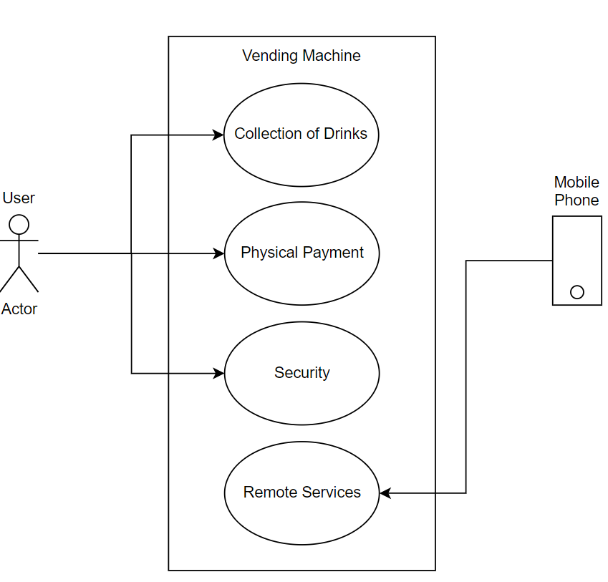

## System Architecture

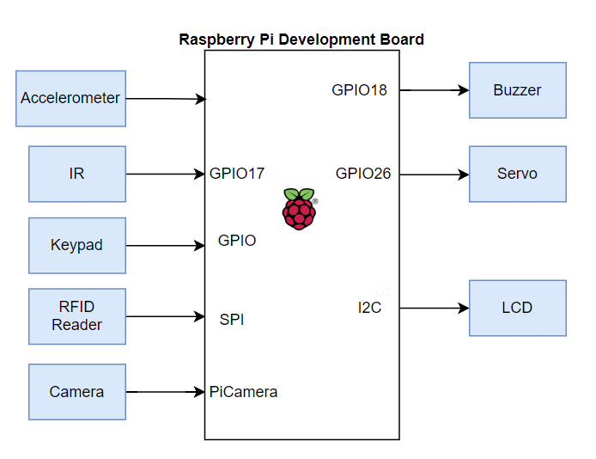

## Functional Requirements

### Function Menu

|  |  |
| --- | --- |
| **REQ_ID** | **Requirement** |
| REQ-01 | The main menu with the text below shall be displayed on the LCD screen  Line 1 = “1. Collect Drink”  Line 2 = “2. Purchase” |
| REQ-02 | In the main menu defined in REQ-01, if the option “2. Purchase” is selected on the keypad, then the following menu shall be displayed on the LCD screen  Line 1 = “1. Milo”  Line 2 = “2. 100 Plus” |
| REQ-03 | In the main menu defined in REQ-01, if the option “1. Collect Drinks” is selected on the keypad, then the following menu shall be displayed on the LCD screen  Line 1 = “Face QR code” Line 2 = “Towards Camera” |

### Collection of Drinks

Collection of drink/s purchased via their mobile phones or website is via a QR code that is generated by the website or mobile App and scanned by a camera connected.

|  |  |
| --- | --- |
| **REQ_ID** | **Requirement** |
| REQ-04 | From the main menu, if the user selects “Collect Drink” then the flowchart defined in Figure 1 shall be implemented. |

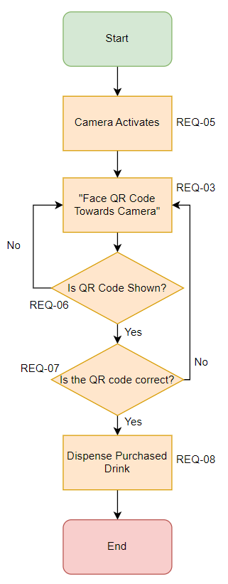  
 **Figure 1**

### Physical Payment

Figure 2 will show the flowchart for the first drink, Milo however it is the same flowchart for the second drink 100 Plus.

|  |  |
| --- | --- |
| **REQ_ID** | **Requirement** |
| REQ-09 | From the main menu, if the user selects “Purchase” then the flowchart defined in Figure 2 shall be implemented. |

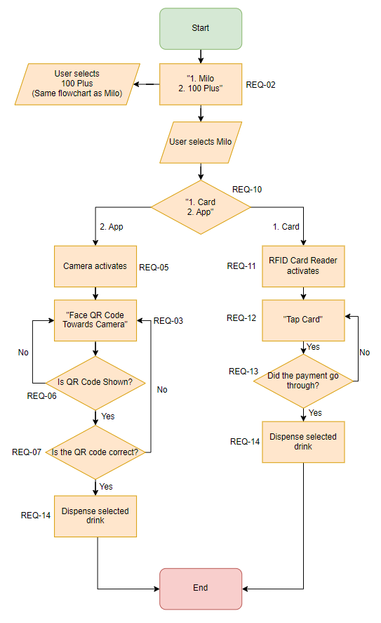

**Figure 2**

### 2.3.4. Detect Door Open

If there are service technicians and drinks suppliers, they need to enter a valid user code on the keypad in order to open the vending machine door without triggering the buzzer alarm.

|  |  |
| --- | --- |
| **REQ_ID** | **Requirement** |
| REQ-15 | The security systems to detect whether the door is being pried open shall follow the flowchart defined in Figure 3. |

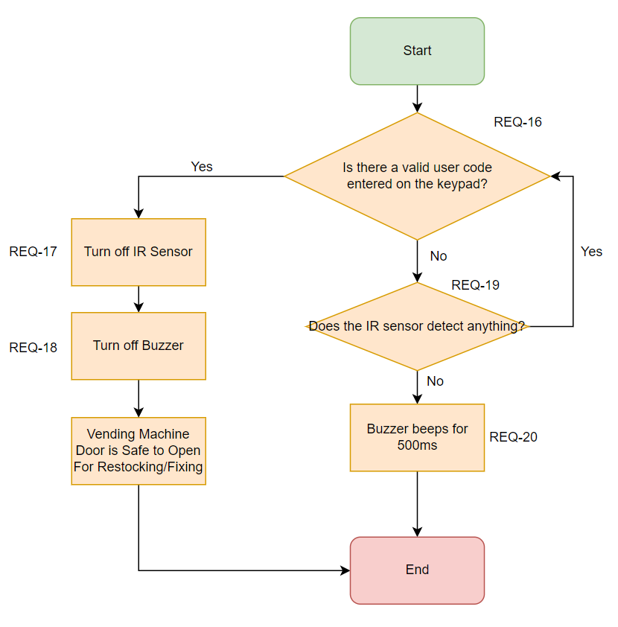

**Figure 3**

### 2.3.5. Detect forcefully open

If the vending machine detects that there has been an attempt to forcefully open it then the buzzer shall be activated.

|  |  |
| --- | --- |
| **REQ_ID** | **Requirement** |
| REQ-21 | The security systems to detect whether the vending machine is being forcefully open shall follow the flowchart defined in Figure 4. |

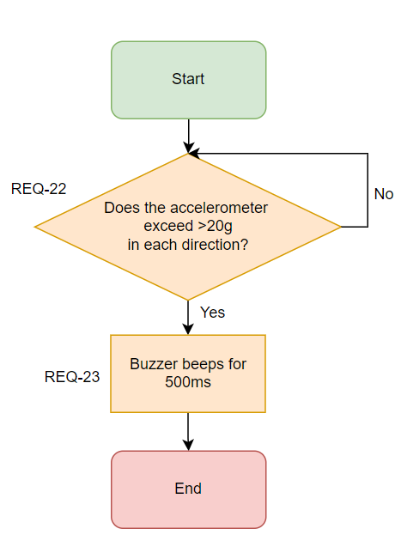  
  
 **Figure 4**

### 2.3.6. Remote Services

The vending machine supports “Remote Access” to remotely purchase the drinks online

|  |  |
| --- | --- |
| **REQ_ID** | **Requirement** |
| REQ-24 | The user shall be able to login to the IP address of the IoT Smart Vending Machine to view a web page or login to an app for the purchasing of drinks in the Smart Vending Machine |
| REQ-25 | The internal Web Server and app on the IoT Smart Vending Machine shall allow the user to purchase the following using their card or balance in their account,  - 100 Plus  - Milo |
| REQ-26 | The internal Web Server and app will generate a barcode/QR code should they purchase a drink through their mobile phones which they get it scanned at the IoT Smart Vending Machine to collect their drink. |
| REQ-27 | The app also can generate a barcode/QR code to scan and deduct from the balance of their account should they want to purchase it at the smart vending machine instead. |

## Non-Functional Requirements

### Power Management

The Smart Vending Machine has 2 Power Modes as defined in the Power State Machine diagram in Figure 5 below. The transitions between the Low Power Mode and High Power Mode are triggered by the events labelled “EnterLPM” and “EnterHPM”.

Conditions for trigger the events are defined in the requirements below.

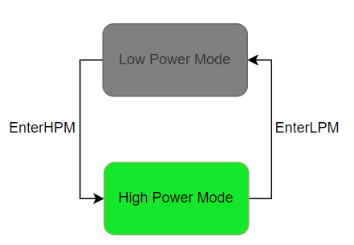

**Figure 5**

|  |  |
| --- | --- |
| **REQ_ID** | **Requirement** |
| REQ-29 | **“EnterLPM” Trigger Condition**  If the vending machine does not detect any user input for more than 60 seconds, the LCD screen and back light will turn off. |
| REQ-30 | **“EnterHPM” Trigger Condition**  When the user presses any button on the keypad, the LCD screen and back light will turn back on and follow REQ-01 |

# Software Architecture

## Static Software Architecture

The Software Architecture defines the various Software Components that are developed to realize the implementation of the system requirements.

**Application Layer**

**Hardware Abstraction Layer (HAL)**

